PCB Tester Requirements

This board:

* 12V input
* GND
* Teensy 3.5

Dashboard:

* 12V switchable power
* 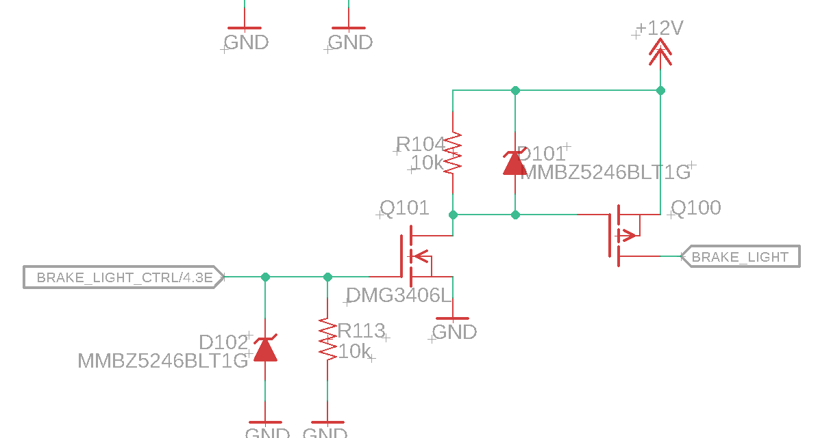
* CANL
* CANH
* GND
* 5 of 5V pull down
* 2 12V digital inputs (don’t need button tests)
  + SSOK (chainable as ECU output Shutdown E) (jumper)
  + Shutdown H
* 1 5V analog input (op amp from Teensy 3.5 output) (with filter) (opamp buffer+filter) (https://www.pjrc.com/teensy/teensy31.html)
* 1 3.3V output read (pull up) 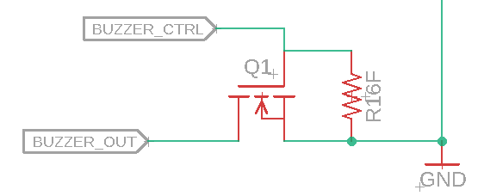

Main ECU:

* 12V switchable power
* CANL
* CANH
* GND
* 4 digipot wheel speed circuitry tester
  + Separate all 4 555 timer gnd to n channel power circuit control shutting off for synchronization
  + 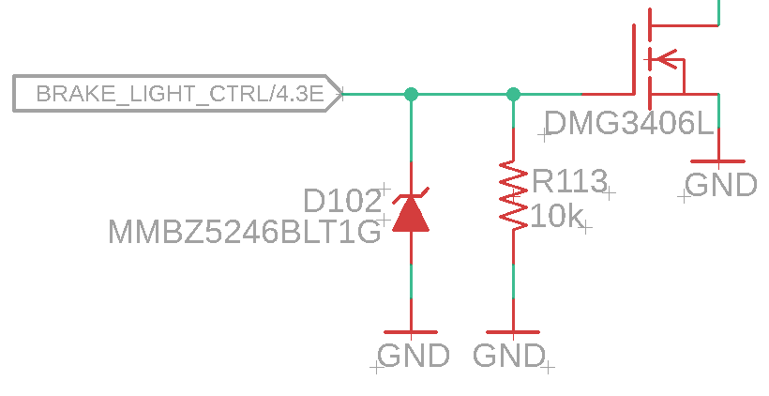
* 12V digital out (pull down)
  + SHUTDOWN E (chainable to dashboard and HV board)
  + INVERTER CTRL
  + BRAKE LIGHT
  + 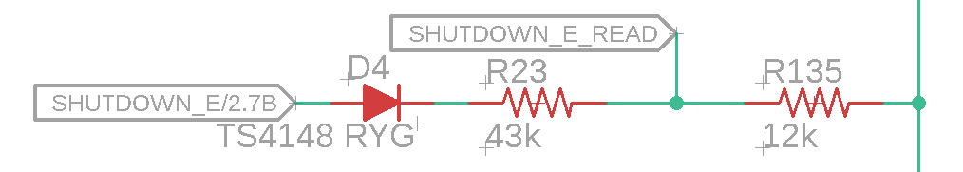
* 4 5V analog signals
  + DAC (Josh has more info)
* 3 1A fan inputs
  + 2 with on-board feedback
* 2 12V IN (buttons)
  + BMS OK(chainable as HV outputs)
  + IMD OK (chainable as HV outputs)
  + 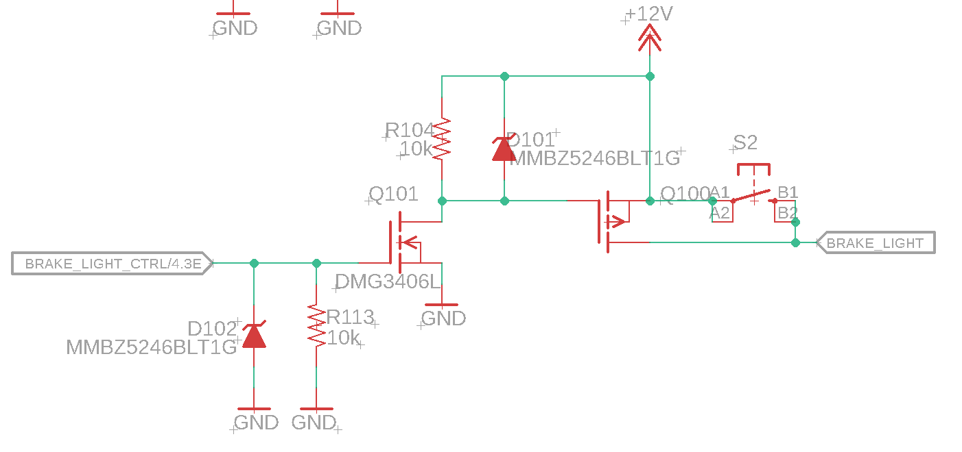
* 1 button pull down
* 12V analog in (DAC)
  + Josh knows more about this chip
  + Chainable from HV output
  + Switch between DAC and HV board (DO NOT USE A JUMPERR!!!)

HV board:

* 12V switchable power
* CANL
* CANH
* GND
* 4 5V analog inptus
  + DAC
* 1 5V digital output (pull down) (TSAL)
* 2 12V digital input
  + SHUTDOWN E(can be from ECU) (jumper)
  + IMD OK
* 12V digital output
  + Charge enable
  + BMS OK (can go to ECU)
  + IMD OK (can go to ECU)
  + 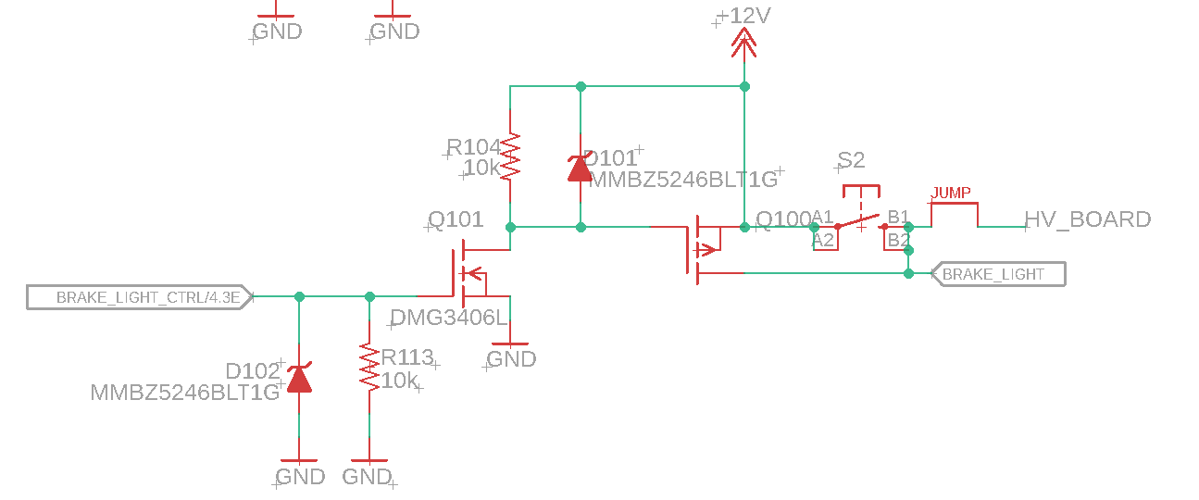
* 12V analog output (chained to ECU)
  + Use Teensy 3.5 analog read
  + Can go to ECU
* Energy meter: (figure this out)
  + 12V
  + GND
  + CANH
  + CANL
* 2 – pin connector with button
  + Digital 12V chain (out side of connector is power) connect to other side
* 2-pin 5V out
* 2-pin ground pull down read
* 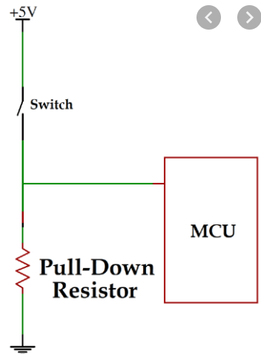
* 2-pin connector
  + 1 pin is ground
  + 1 pin is 12V output read

Noise testing:

* Dashboard analog circuitry + duplicate of it
* 4 pin connector
* 2 output channels teensy -> two jumpers, one for each connector